Quality Policy Statement (QMP01)
Care Plus Group is a Social Enterprise – profits made by Care Plus are reinvested into the development and delivery of health and social care services locally ensuring that the Care Plus Group remains the provider of choice for the people of North East Lincolnshire. It is therefore the policy of the Group to maintain a quality system in pursuit of its primary objectives, the purpose and the context of the organisation.
Care Plus demonstrates its commitment to quality through the following:
- Compliance with Codes of Practice and the requirements of ISO 9001:2015; Care Quality Commission Care Standards and associated statutory regulations and requirements.

- Continual improvement and measurement of Care Plus Group service performance; the supporting quality system; individual staff members’ performance and overall performance of Care Plus Group.

- Commissioner required quality performance indicators charted into our Heads of Service ‘Quarterly Performance Reports’.

- Planning and review of our strategic objectives ‘what’s important to us’. Planning commences with the Council of Governors (CoG) strategy meeting / outcome presented to the Leadership Team / discussion at the Non Executives meeting / staff consultation at the CPG Connect event. The finalised master plan is then submitted to our Board for sign-off and then allocated to Heads of Service/Directors to deliver with individual objectives for all staff to be considered within the PDR process. The Heads of Service/Directors produce individual action plans for the overarching SMART objectives, with bi-monthly updates on progress submitted to our Board.

- Effective communication of the requirements of our quality management system to all Care Plus Group staff and Non Executives including service requirements and associated service key performance indicators (KPI’s).

- Involving and developing all Care Plus Group staff in innovation, problem solving and resultant improvements to our services.

- Provide staff with the necessary equipment and training to maintain their knowledge and skills in order that they can fulfil their roles competently and safely.

- Strive to satisfy the requirements of all of our customers, stakeholders and other interested parties whenever possible, meeting and exceeding their expectations.

- Monitoring reviews and continuous improvement of the Quality Management System, which is undertaken through the management review process on a minimum quarterly basis, the Leadership Team meetings, and staff innovation suggestions, at process approach reviews, internal/external audits and in the event of any newly identified issues/inputs.

- Reviewing this Quality Policy via the management review process on a minimum quarterly basis ensuring that it remains fit for purpose and is communicated across the whole of Care Plus Group and to other interested parties and to be signed and dated annually.
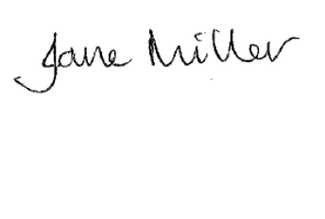
This quality policy is authorised by

Jane Miller,
Chief Executive
Care Plus Group

Date: 18th September 2020
QMP/Issue No.9

